Coming VACANT- August Sale 2018

$411,000 - Buy TEKAM now

‘First time for Sale since 1996’

9 TEKAM CRESENT, TANAH MERAH Q 4128

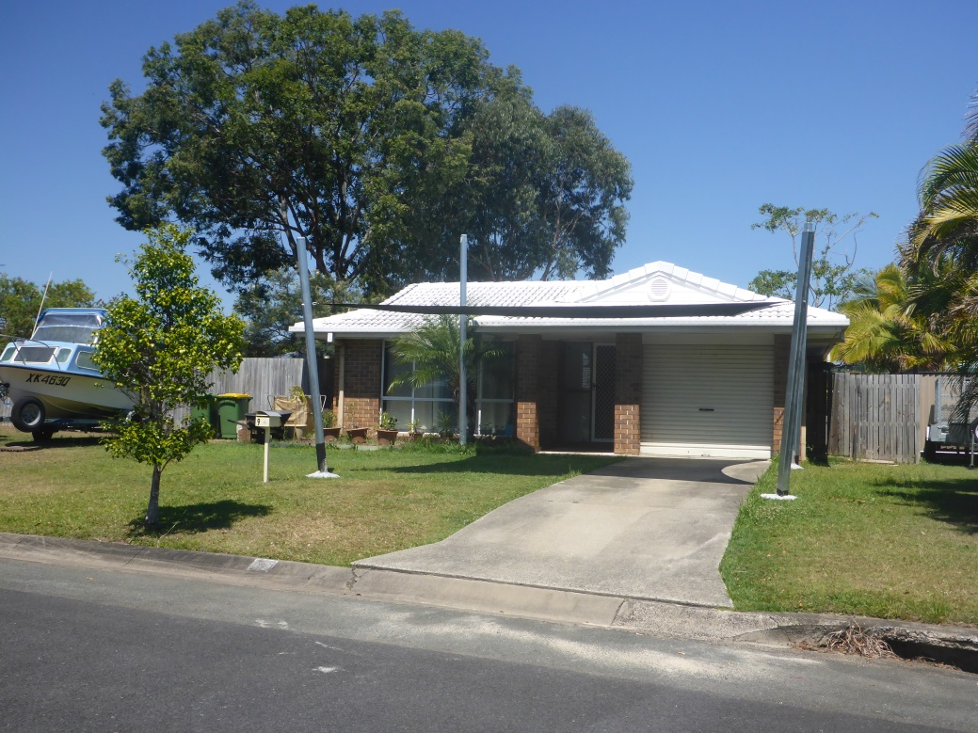

714m2 fenced large block, 4x beds, 2x baths, 2x car accomm,
2x Air conditioners, Quiet Tanah Merah Estate

- Main bedroom with Ensuite and air conditioned
- Main bathroom with separate hallway toilet
- Laundry off hallway
- Open plan dining and electric kitchen
- Separate carpeted lounge area and air conditioned
- Lock up garage and/or storage plus front free standing shade pergola

******* Will be Vacant from Sat 4th August 2018 ********
Open homes will be every Tuesday, Thursday and Saturday 11.30am to 12.30pm

UNLESS SOLD PRIOR WITH AGENT KERRYN HANRAHAN
OWNER OF RED SPOT REALTY-RENTALS & SALES SINCE 1996
Emails only to - Kerryn@redspotrealty.com.au

